Table of Contents

1.0 Getting to know the user interface 2

1.1. Tool strip menu items 3

1.2. Picture box 3

1.3. Transport controls 4

1.4. Chart 4

1.5. Details 5

1.6. Image comments 5

1.7. Segment controls 6

2.0 How to use the software 7

2.1. Open a folder containing images 7

2.2. Process segmentation 8

2.2.1. Add new segment 8

2.2.2. Delete existing segment 8

2.2.3. Classify segment 8

2.2.4. Clear segmentation 9

2.3. Export to CSV 9

3.0 Preferences 10

3.1. Preferences (basic) 10

3.2. Preferences (advanced) 10

Appendix 1 – Keyboard Shortcuts 12

Toolstrip menu items 12

Transport controls 12

# Getting to know the user interface

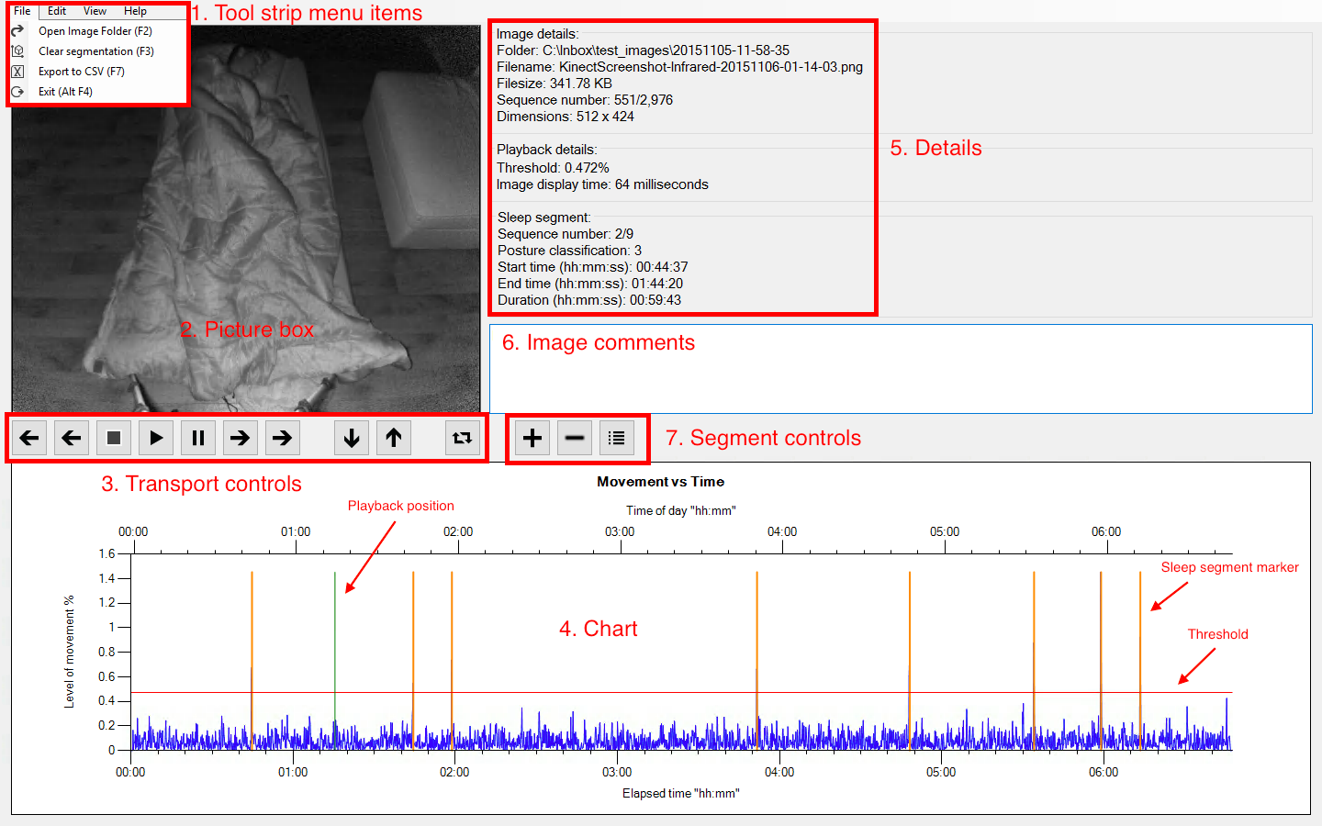

## Tool strip menu items

The menu at the top of the screen allows the user to trigger specific actions associated with the software.

|  |  |  |  |
| --- | --- | --- | --- |
| Menu | Item | Keyboard Shortcut | Function |
| File | Open Image Folder | F2 | Opens a dialog window to allow the user to select a folder containing images to be loaded. Initial folder shown can be set using the “Default folder location” setting in the preferences. |
| File | Process Segmentation / Clear Segmentation | F3 | Before segmentation has been processed, selecting this menu item will process segmentation. After segmentation has been processed selecting this menu item will clear all segmentation. |
| File | Export to CSV | F7 | This menu item is only available when segmentation is processed and it exports all of the session data to a folder called “output.csv” in the folder containing the images. |
| File | Exit | Alt + F4 | Exits the program and discards all saved data. |
| Edit | Preferences | F8 | Opens the Preferences (basic) window. |
| View | Toggle Full Screen | F11 | Toggles between full screen and window mode. |
| Help | View Help | F1 | Opens the PDF help document in the default Windows program for reading PDF files. |
| Help | About | None | Opens a window displaying brief information about the software. |

## Picture box

Displays the relevant image correlating to the timeline in the chart. When two series of images are loaded the image shown in the picture box can be changed by clicking the “toggle image” button in the transport controls.

## Transport controls

Transport controls allow the user to navigate through the image series as if they are watching a movie. The function of each control, from right to left, is explained in the table below:

|  |  |
| --- | --- |
| Icon | Function |
|  | Navigate back to previous sleep segment marker. |
|  | Navigate backward by one frame. |
|  | Stop – stops playback of image series and resets the play back position to the start of the series. |
|  | Play – initiates playback of image series. |
|  | Pause – pauses playback of image series without resetting the play back position. |
|  | Navigate forward by one frame. |
|  | Navigate forward to next sleep segment marker. |

## Chart

The chart shows time vs level of movement and contains two X axis, the top one being time of day of the image, and the bottom one being elapsed time. Key functionality associated with the chart is explained in the table below.

|  |  |  |
| --- | --- | --- |
| Detail | Description | Function |
| Frame differences | Blue line | Indicates the level of difference between two images in the series. Spikes indicate significant difference and indicate where a movement may have occurred. |
| Playback position | Vertical green line | Clicking the chart allows the user to drag the playback position line to change the play back position and this is known as real time scrubbing”. |
| Threshold | Horizontal red line | Clicking the red line and dragging it up and down allows the user to change the threshold value used in segmentation processing. Once segmentation is processed, the threshold line cannot be modified unless segmentation is cleared. |
| Sleep segment marker | Vertical orange lines | Sleep segment markers indicate the points where sleep position changes. Markers can be added and removed by using the segment controls. |

## Details

The details section is broken into three subsections which are explained in the table below

|  |  |
| --- | --- |
| Section | Function |
| Image details | Displays the details associated with the image currently displayed including:   * Folder * File name * File size * Sequence number * Image dimensions |
| Playback details | Displays details associated with the playback of the image including:   * Threshold (used when segmentation is processed) * Image display time (“playback speed” when image sequence is viewed as movie) |
| Sleep segment details | After segmentation is processed, this section displays the following details relating to the sleep segment associated with the current playback position:   * Sequence number * Position classification * Start time (relative) * End time (relative) * Duration |

## Image comments

The user is able to enter comments for each frame in the image series. The comments are saved when the image displayed changes. Saved comments are included when the session data is output to output.csv.

## Segment controls

|  |  |
| --- | --- |
| Icon | Function |
|  | Create sleep segment – inserts a new orange line into the chart to split an existing sleep segment into two sleep segments. |
|  | Remove sleep segment – deletes an orange line from the chart to merge two sleep segments. Classification details associated with the current segment will be lost in the merge. Only active when playback position is on a sleep segment marker. The sleep segment navigation buttons in the playback controls are useful for navigating the playback position to the correct location to activate this functionality. |
|  | Classify sleep segment – opens a new window to allow the user to assign a position classification between 1 and 16 to the sleep segment. Sleep segments are initially classified 0 and once they are assigned a higher classification they cannot be reverted back to this initial classification. |

# How to use the software

## Open a folder containing images

Click “File” from the tool strip menu, then select “Open Image Folder”. A dialog box will open to allow the user to select the folder containing the images. If the user has set the default folder option in the preferences, then this default folder will be opened when the dialog box is shown.

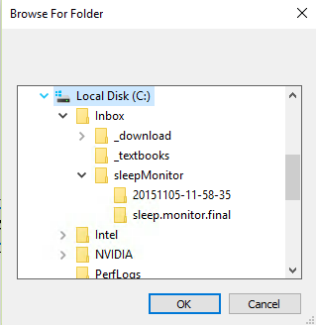

Selecting “OK” will load the images into the program according to the whitelisting rules set in the advanced preferences. If “Cancel” is selected the dialog box will close and no images will be loaded.

If there are already images loaded into the program and the user attempts to load new images into the program, they will be shown the warning in the screenshot below:

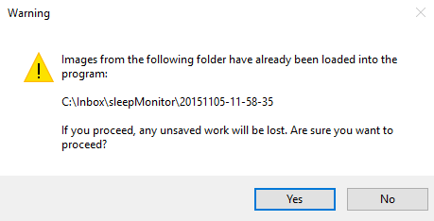

## Process segmentation

The software automates the task of splitting the image series into segments where there are points of movement. The threshold used to determine movement is represented by the horizontal red line on the chart and can be increased and decreased by clicking it and dragging it up and down. Once segmentation is processed the threshold line can no longer be modified unless segmentation is removed. If segmentation is processed where there are no peaks exceeding the threshold, the entire image series will be a single sleep segment.

The Preferences (advanced) window allows the user to set a value for look ahead processing and the default is set to 5 frames. This means that when the software detects a level of movement exceeding the threshold, it looks ahead 5 frames to determine if there is a larger amount of movement and will insert the segmentation marker the point correlating to the largest movement within the 5 frame range. This feature is to prevent multiple segmentation markers from being inserted for a single movement event. The feature can be disabled if desired by changing the setting to 0 frames.

### Add new segment

If the user detects a point in the image series where they would like to insert a segment marker, they can achieve this by navigating to the desired location using either real time scrubbing or playback controls and then selecting “Add sleep segment” from the segment controls. A new vertical orange line will then be inserted in the chart and the segment will be available for classification.

### Delete existing segment

If the user detects a sleep segmentation marker that is a false positive and not related to movement event, they can remove it by first adjusting the playback position is on the marker they wish to remove, and then selecting “Remove sleep segment” from the segment controls. The orange line will then be removed from the chart and the sleep segment will be merged with the previous sleep segment. The sleep segment navigation buttons in the playback controls are useful for navigating the playback position to the correct location to activate this functionality.

### Classify segment

Each sleep segment can be assigned a classification number between 1 and 16 by selecting “Classify sleep segment” from the segment controls. Sleep segments are initially classified 0 and once they are assigned a higher classification they cannot be reverted back to this initial classification. The window in the screenshot below is opened and the user is required to select an option or cancel.

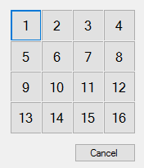

### Clear segmentation

If the user wishes to use the automated segmentation functionality again (possibly after adjusting the threshold), they must first clear existing segmentation. This is achieved by selecting “File” from the tool strip menu, then “Clear Segmentation” which is in the same location that “Process Segmentation was previously.” Before proceeding, the user will be asked to agree to the following warning message:

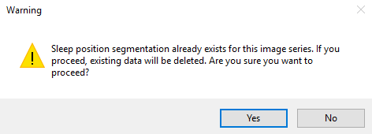

## Export to CSV

Once the user has finished classifying their sleep segments and has entered comments where appropriate, they can export the data to a CSV file which can later be opened in a spreadsheet program, such as Microsoft Excel, or a text editor program, such as Notepad.

To export to CSV select “File” from the tool strip menu, then “Export to CSV”. The file “output.csv” will now be saved in the same folder as the image series. If the file already exists then the user will be prompted to decide whether or not to overwrite the existing file. If the file cannot be written to, such is when it is already open in Microsoft Excel, then the user will be shown an error message explaining why the write operation could not be completed.

# Preferences

## Preferences (basic)

When Preferences is selected from the Edit tool strip menu item, or the keyboard shortcut F8 is pressed, the basic preferences window and is shown as per the screenshot below:

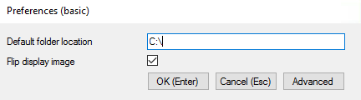

## Preferences (advanced)

When the advanced button is clicked the advanced preferences window is opened which contains the two preferences shown in the basic window as well as others:

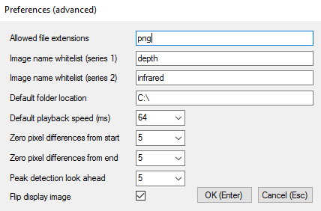

The functions of the different preference items are outlined in the table below:

|  |  |  |
| --- | --- | --- |
| Preference | Basic | Functionality |
| Allowed file extensions | No | List of file extensions allowed when new images are loaded into program. Must have at least one entry. Default is “png”. |
| Image name whitelist (series 1) | No | Whitelist term for images to be loaded into series 1 which is series used to calculate pixel differences displayed in chart. If field is blank then all images in input folder will be attempted to be loaded. Default is “depth”. |
| Image name whitelist (series 2) | No | Whitelist term for images to be loaded into series 2 which provides alternative display images. If field is blank then alternative display images will be unavailable. Default is “infrared”. |
| Default folder location | Yes | Default location opened when loading new images into program. Default is “C:\”. |
| Default playback speed (ms) | No | Allows the user to set the default playback speed. Default is 64. |
| Zero pixel differences from start | No | Zeros out pixel differences by number of frames at start of series to avoid spikes relating to set up which affect scale on chart. Default is 5. |
| Zero pixel differences from end | No | Zeros out pixel differences by number of frames at end of series to avoid spikes relating to shut down which affect scale on chart. Default is 5. |
| Peak detection look ahead | No | Number of frames to look ahead when pixel difference exceeding threshold is detected. Avoids having multiple consecutive segment markers relating to a single movement. Maximum value in look ahead range is taken as segment point. Default is 5. |
| Flip display image | Yes | Flips image on x axis before displaying in image box. Default is checked. |

When “OK” is clicked in either the basic or advanced preference windows, the settings are saved and the window exits. Clicking “Cancel” disregards any changes and closes the window.

All fields are checked for validity when “OK” is pressed. Any invalid input will trigger and error and the user will be given the opportunity to address the error before the click “OK” to attempt to save and exit again.

# Appendix 1 – Keyboard Shortcuts

## Toolstrip menu items

|  |  |  |
| --- | --- | --- |
| Primary key | Secondary key  (if required) | Action |
| F1 |  | Help |
| F2 |  | Open prompt to load new images |
| F3 |  | Process segmentation |
| F4 | Alt | Close program |
| F7 |  | Export to CSV |
| F8 |  | Open preferences |
| F11 |  | Toggle between full screen and windowed mode |

## Transport controls

|  |  |  |
| --- | --- | --- |
| Primary key | Secondary key  (if required) | Action |
| Space | Alt | Toggle between play and pause |
| ~ (tilde) | Alt | Stop playback |
| Left | Alt | Navigate backward by one frame |
| Right | Alt | Navigate forward by one frame |
| + | Alt | Increase playback speed |
| - | Alt | Decrease playback speed |
| | (pipe) | Alt | Toggle image display between series 1 and 2 (only functional when two image series are loaded) |
| Down | Alt | Navigate back to previous sleep segment marker |
| Up | Alt | Navigate forward to next sleep segment marker |